Technical Design Document

## *For ETA: All The Counters*

# Document Authors

Aidan Mckeown - Team Lead and Programmer

Sean Volders - Executive Programmer

# Table of Contents

1. Introduction
2. Platforms
3. Target Platforms
4. Technical Specifiactions
5. Asset Specifications
6. Timeline
7. Diagrams and Tables

**1: Introduction**

ETA: All The Counters, is a fast paced action fighting game where only skill matters and the blocks don’t exist. The key difference between this game and most generic fighting games is the simple fact that the only attack is a ranged attack, there are no combos, and to not take damage you must either dodge or counter this attack. There is no block mechanic.

**The Team:**

Designer

* Nathan Mell

Programmers

* Aidan Mckeown
* Sean Volders

Artists

* Harry Vernon
* Anderson Nguyen
* Lochlan Cook

**2: Platforms**

* 1. ***Target Platform***Eta will be targeted for the PS3, PS4 , Xbox360 and Xbox One.  
     There will also be a PC port, however the controls are not designed for anything but controller input.
  2. ***Technical Specifications***We will be building for the lowest common denominator in terms of performance capabilities. With the lowest CPU and GPU performance, we will be aiming for high frame rates on an Xbox360, with the specs being equivalent roughly to a PC as follows.

**MIN specs**  
CPU: Skylake i3 – 6100  
GPU: Radeon 7770  
RAM: 2gb DDR3 at 800Mhz  
HDD: 256gb HDD

Memor*y* required for install: ~250MB

**3: Assets Specifications**

Character Data

* + 4 Character models
  + 2 specialised projectiles for each character
  + Any assets needed on a per individual basis for special attacks

Sounds/ Music: *files will be in .WAV format*

* + Counter/ hit sounds
  + Walking/ dashing/ stepping sounds
  + Gameplay Music
  + Voice files for each character for : Attacking, getting hit, jumping

Level data:

* + 1 Level made of basic assets per character that fits each characters individual theme

**4: Diagrams and Tables**

**Game State flow chart:**

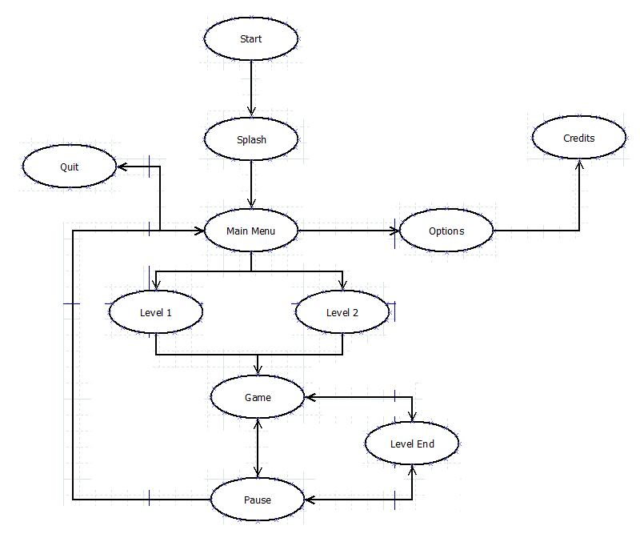

**Scripts:**

|  |  |
| --- | --- |
| **Script** | **Description** |
| ArrowMovement | Controlls the projectiles that are fired by the player |
| AudioScript | Manages the sound, running when sound is required. |
| CameraPos | Controls the camera as it lerps around following the players |
| EdgeDetection | Gives the Bold Outlines to shapes to give the cool shaded look |
| GameController | Handles Global Variables |
| HealthBarScript /  SpecialBarScript | Controls the UI health and special bar dependant on player health and special values |
| PauseScript | Pauses the game and shows menu UI |
| PlayerController | Handles all player movement and firing mechanics |
| SpecialBase | A parent script which all special scripts should derive from |
| Special Scripts  for Each Character | A script for each character that makes them do their own specific special attack, derived from the SpecialBase script so it can be handled by all parties. |

**5: Timeline**

|  |  |
| --- | --- |
| **Week** | **Description** |
| 1. Concept Visualisation | Put together details about our game with initial concept art and approval |
| 2. Alpha Build | Started creating our games, getting the core mechanics of the game down and have it playable |
| 3. Alpha Build |
| 4. Alpha Build |
| 5. Alpha Build |
| 6. Beta Build | Began adding extra features to the game and fixing up any problems from alpha |
| 7. Beta Build |
| 8. Beta Build |
| 9. Gold Build | Polished the game and preparing it to run on the VITA and PlayStation 4 |
| 10. Gold Build |
| 11. Gold Build |
| 12. Post Mortem | Complete all post-production documentation |